# 500PX Demo

### Purpose

The purpose of this document is to explain how to get the 500PX demo app running and how it works. This 500px demo app is developed as part of the interview process for BNOTIONS.

### Dependencies

* 500px SDK
  + This library is used to login to 500px service and sign requests using OAuth 2, as well as browse and search images.
* ActionBar-PullToRefresh Library
  + This library is used to enable a swipe down gesture to refresh the image grid, as well as replace the ActionBar with one that has a progress bar and replace the title with ‘Refresh text’. This is just like the refresh functionality of the new Gmail.
* AndroidSlidingUpPanel Library
  + This library is used to create a sliding panel in the bottom of the image that contains interaction elements such as comments and likes.
* PhotoView Library Library
  + This library is used to create high quality ImageViews that support multi-touch zoom, double tap zoom, multi-touch pan, as well as single touch pan
* Picasso Library
  + This library is used to download and cache images, as well as handle placeholders and errors
* Google Play Services Library
  + This library is used to display Maps using Google Maps

### Setup and compilation:

1. Unzip the attached 500px.zip file
2. In eclipse: Import the following projects as android projects: 500px-android-sdk, ActionBar-PullToRefresh, AndroidSlidingUpPanel, PhotoView. Make sure that they build
3. Import the Google Play Services library into your workspace. It is available in the Android SDK Manager. I tested using the latest version 12.
4. Import 500px into the workspace. Add the above five projects as dependent libraries
   1. Right click on project and select properties
   2. Select Android in the left hand list
   3. Under Library, Add the five projects from before
5. Build and run.

*Note: although the project will build and run without crashing, at this point the maps will not load due to conflicts between the signing keystore and the API key. To mitigate this, add your own API key the manifest file on line 53

### Rundown

#### Grid View

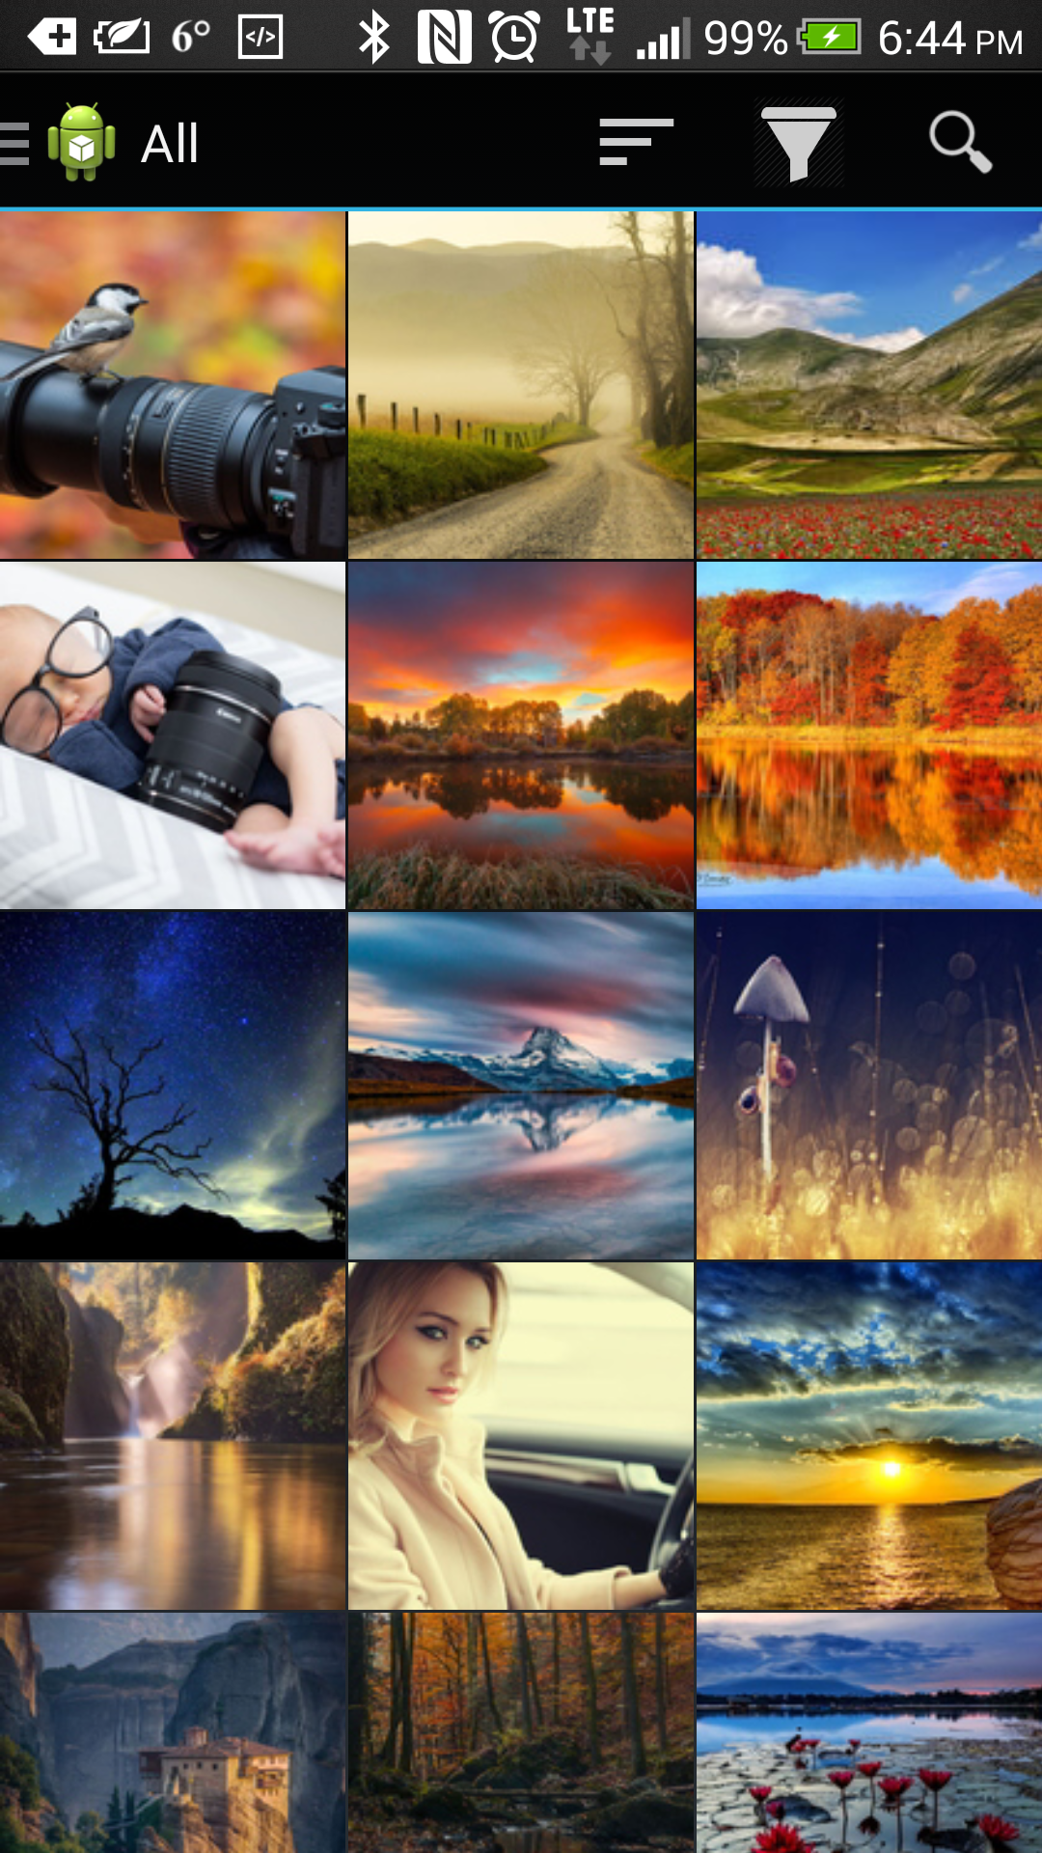

This is the most basic view in the app, and what the user sees as soon as they open the app. No need to login or signup in order to use the app

In the image to the left the user is browsing images in all categories

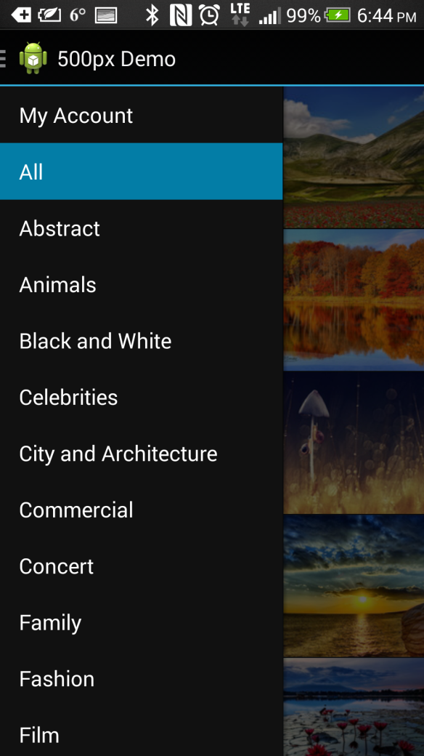In the image below, the user has opened the drawer by clicking on the up button (robot) or swiping from the left edge of the screen. In this view the user can select another category or open their profile page.

Clicking on ‘My Account’ will trigger the login screen

Notice that when the drawer is open the

Action Bar icons are hidden.

In this image the user has swiped down to trigger a refresh of the images. The user has to scroll all the way up, and then scroll again this won’t be triggered by one long scroll.

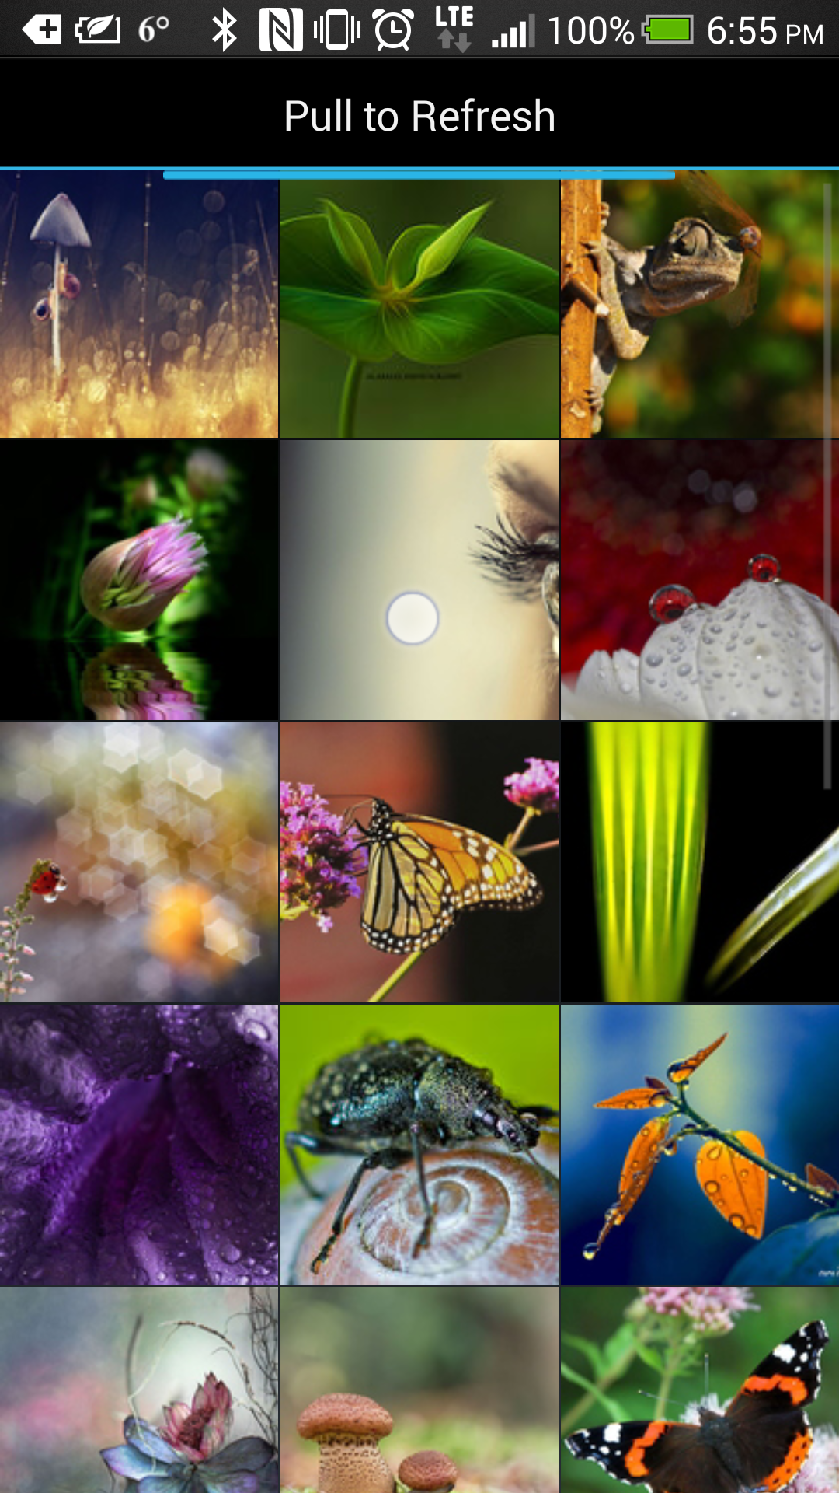

In the next image the user has clicked on the filter icon and is now selecting a filter to help find the images that are the Editor’s choice

When clicking on the filter and sort icons a nice box flies down from the top of the screen with the options available and also applies a dark filter the underling grid

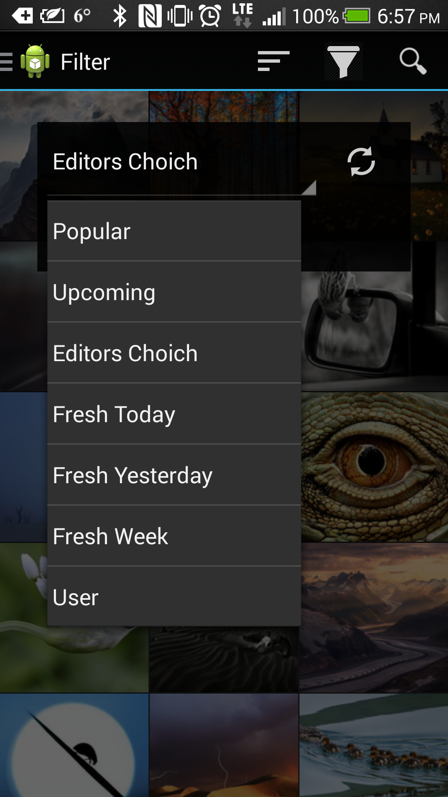

#### Search

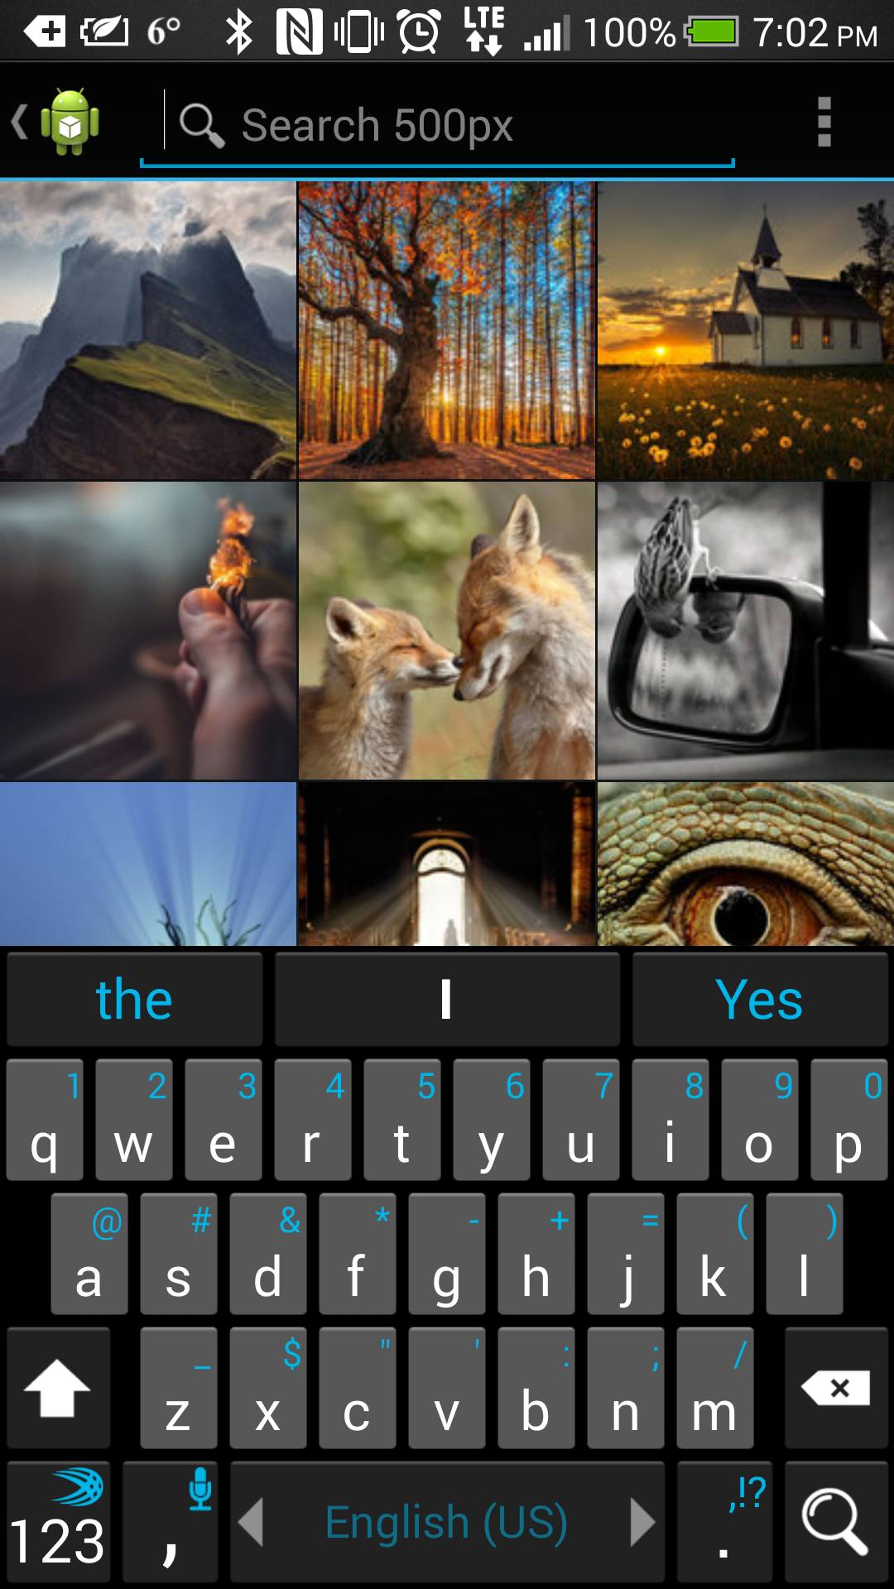

When the user clicks on the search icon a search interface allows him to search directly from the Action Bar.

The Entered search query is then provided the same grid layout, and the search term is set as the title of the View

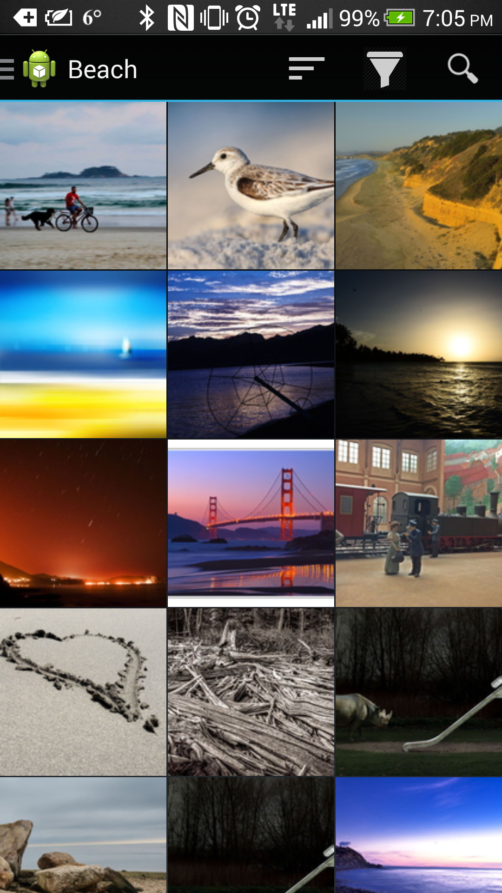

#### Single Image View

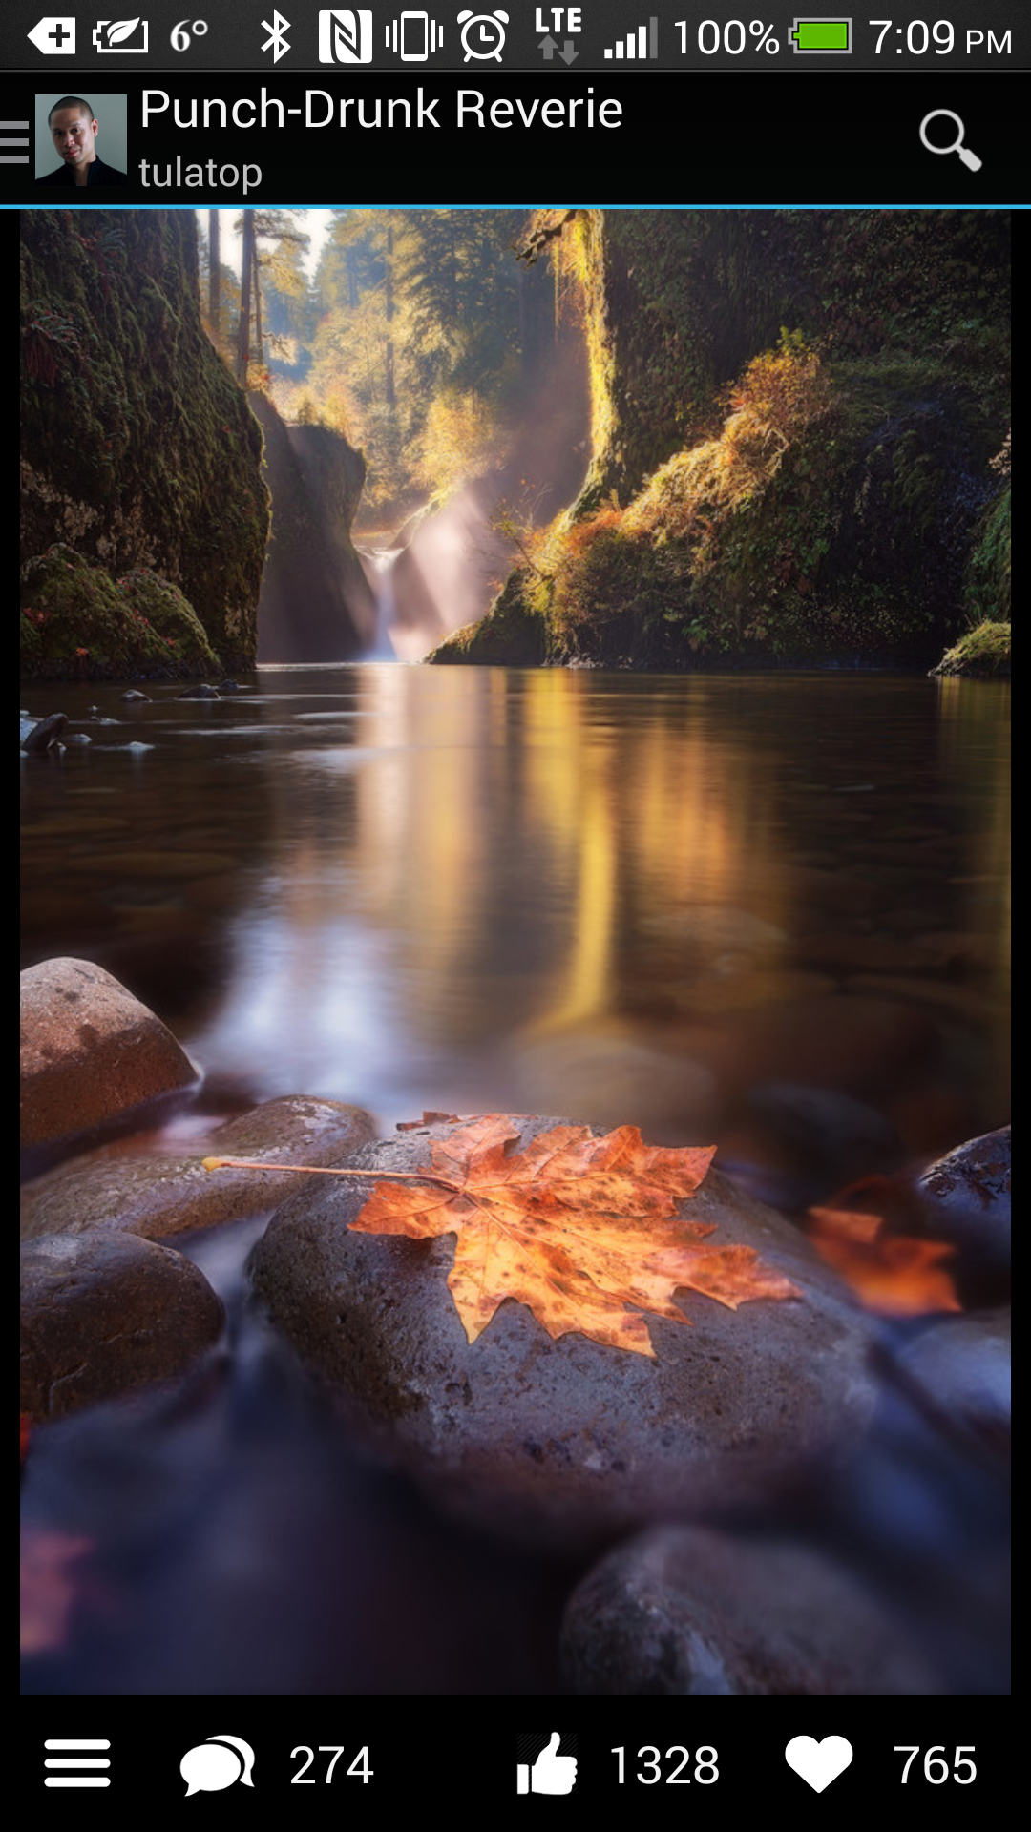

When the user has click on an image in the grid he is presented with a beautiful full resolution image. At this point the user can zoom in and out of the image by double tapping it, or by pinching the image, as well as panning around in order to focus on a specific part of the image.

The app also present the Image’s name and the user avatar of the user who uploaded the image to 500px in the ActionBar

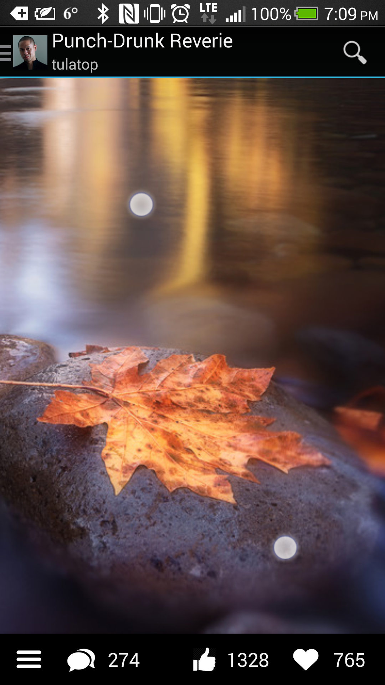

In the bottom the user is presented with 4 icons:

1. Details – Clicking on this will open an overlay panel with some technical details about the image, as well as view count and a map of where the image was taken (if availiable)
2. Comments – Clicking on this will open an overlay panel with comments to the image, as well as an entry box to enter your own comment. (note: this will trigger a login screen if you are not already logged in)
3. Likes – Clicking this will submit a ‘Like’ to the image. (note: this will trigger a login screen if you are not already logged in). Upon a successful ‘Like’ the icon will turn blue to signify a successful that you already ‘Liked’ the image.
4. Favorite – Clicking this will submit a ‘Favorite’ to the image. . (note: this will trigger a login screen if you are not already logged in) Upon successfully ‘Favorite -ing’ and image the icon will turn red to signify that the image is already in your favorites.

Swiping up on the whole bottom row (buttons and clear area) will bring up the comment/details view, while presenting a slick fade in. The fade is from 47% transparency to 86% for the button bar, and 50% to 100% for the details/comments views

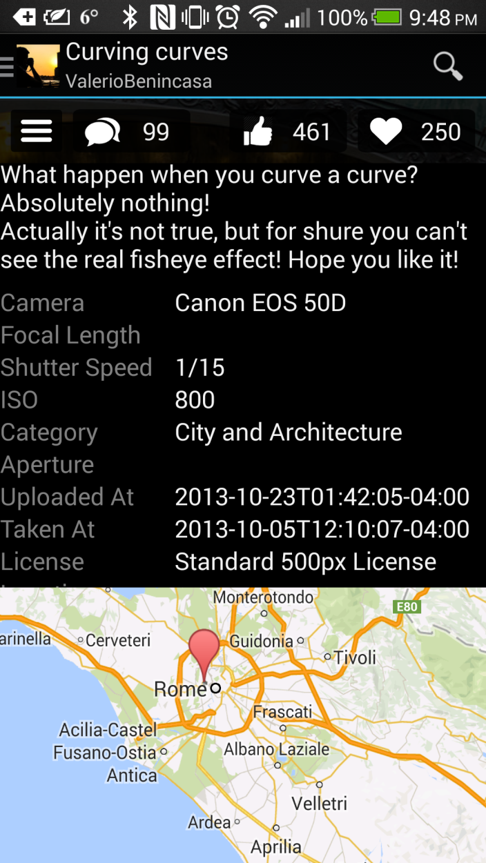The sliding panel can also be anchored 20% from the top and

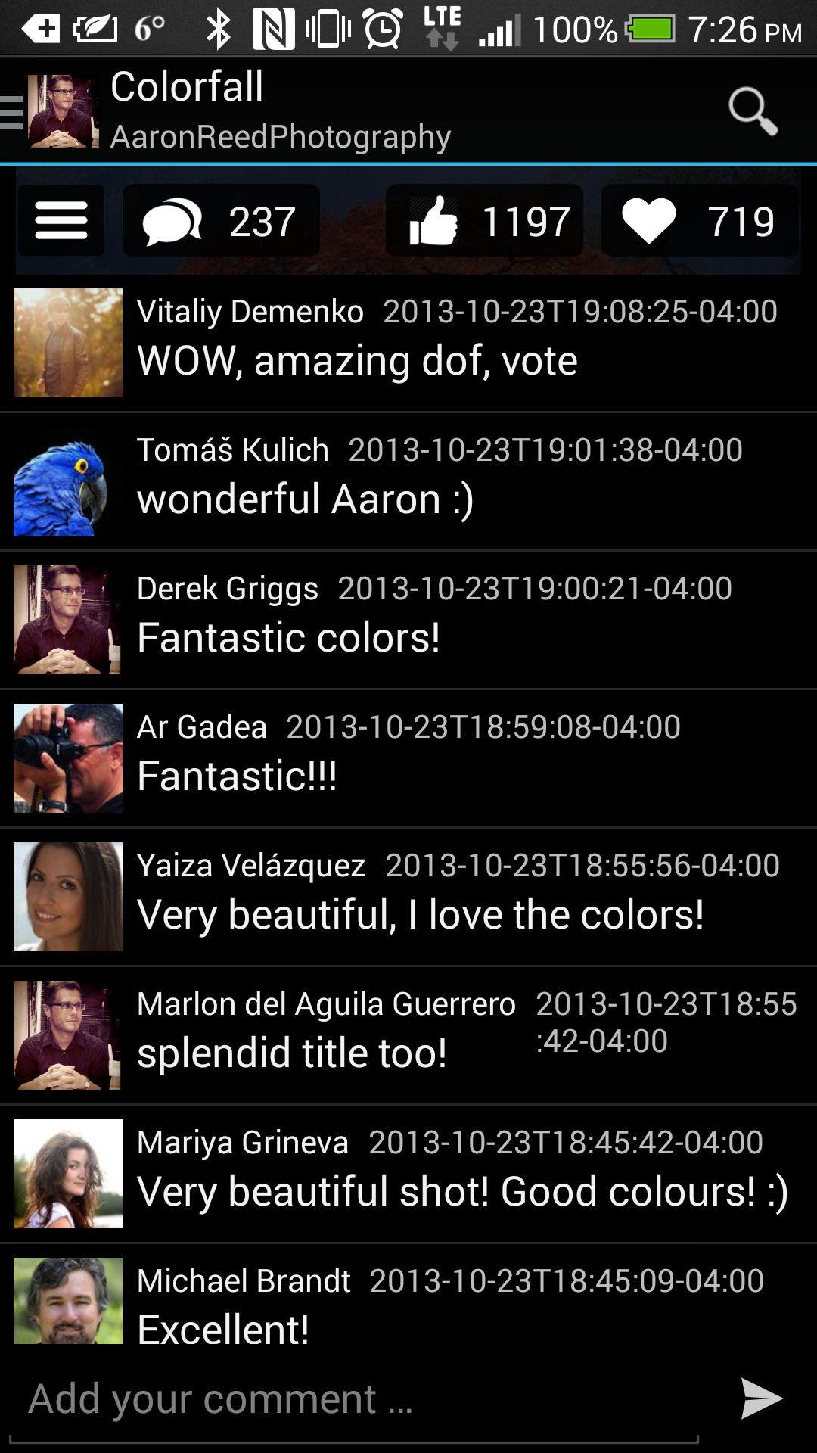

Any action that requires the user to log in (opening my account, liking an image, favorite-ing an image, or submitting a comment) will trigger the login screen. After a successful login, whatever action the user has requested will be taken.

For example: the user finds a picture that he likes, and he would like to leave a comment. The user would type his comment and hit send. The login screen will come up and ask for his credentials. After logging in, he will be returned to the comments screen when his comment will automatically be submitted.

The same happens when liking an image or opening the ‘My Account’ page.

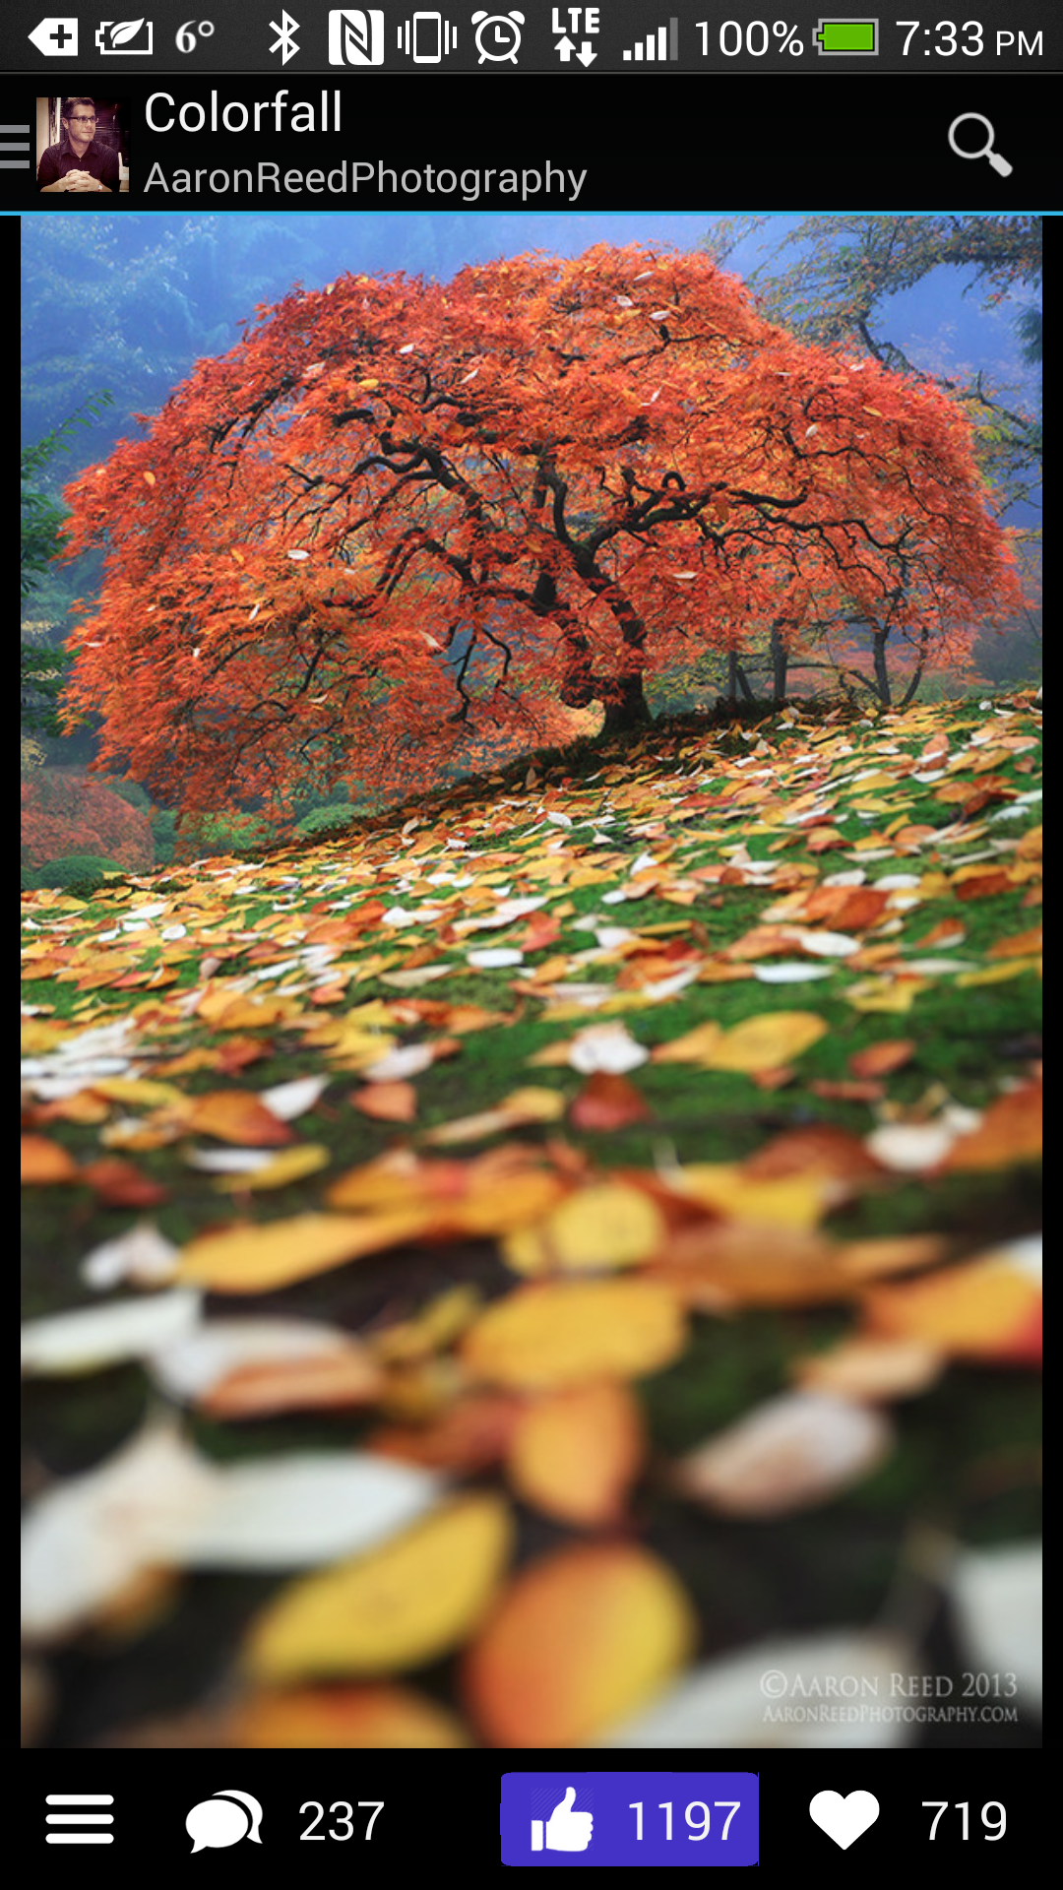

In fact, the only way to trigger a login is by trying to do a task that requires authentication.

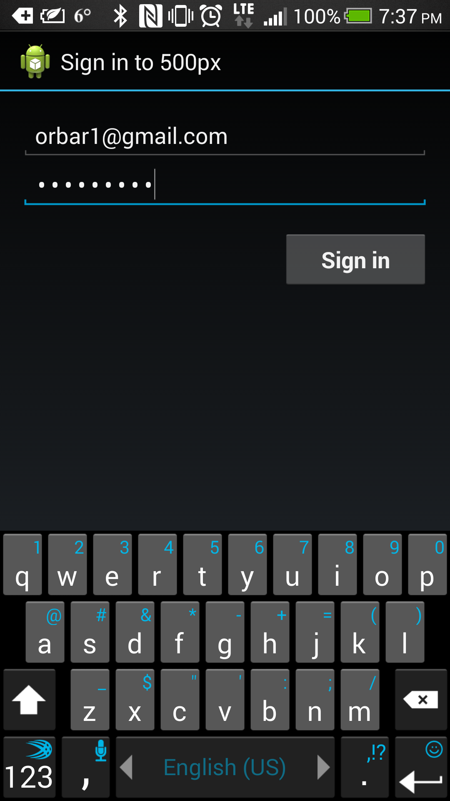

Once a user is logged in to the app, his full name is presented at the top of the drawer and a log out button is added to the bottom of the drawer.

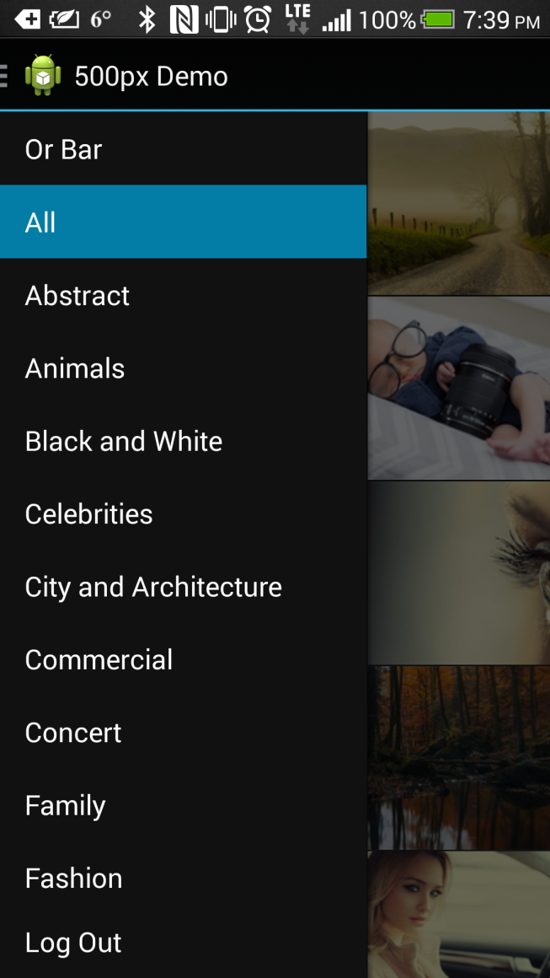Clicking on the user’s name will go to the user account page.

The user’s Account page presents details about the user, such has how many photos he has uploaded, how many followers he has, some information about him and a list of his photography equipment.

The My Account page also has links to the user’s social account pages that open in their respective apps (Facebook and Twitter) or their websites (500px and twitter)

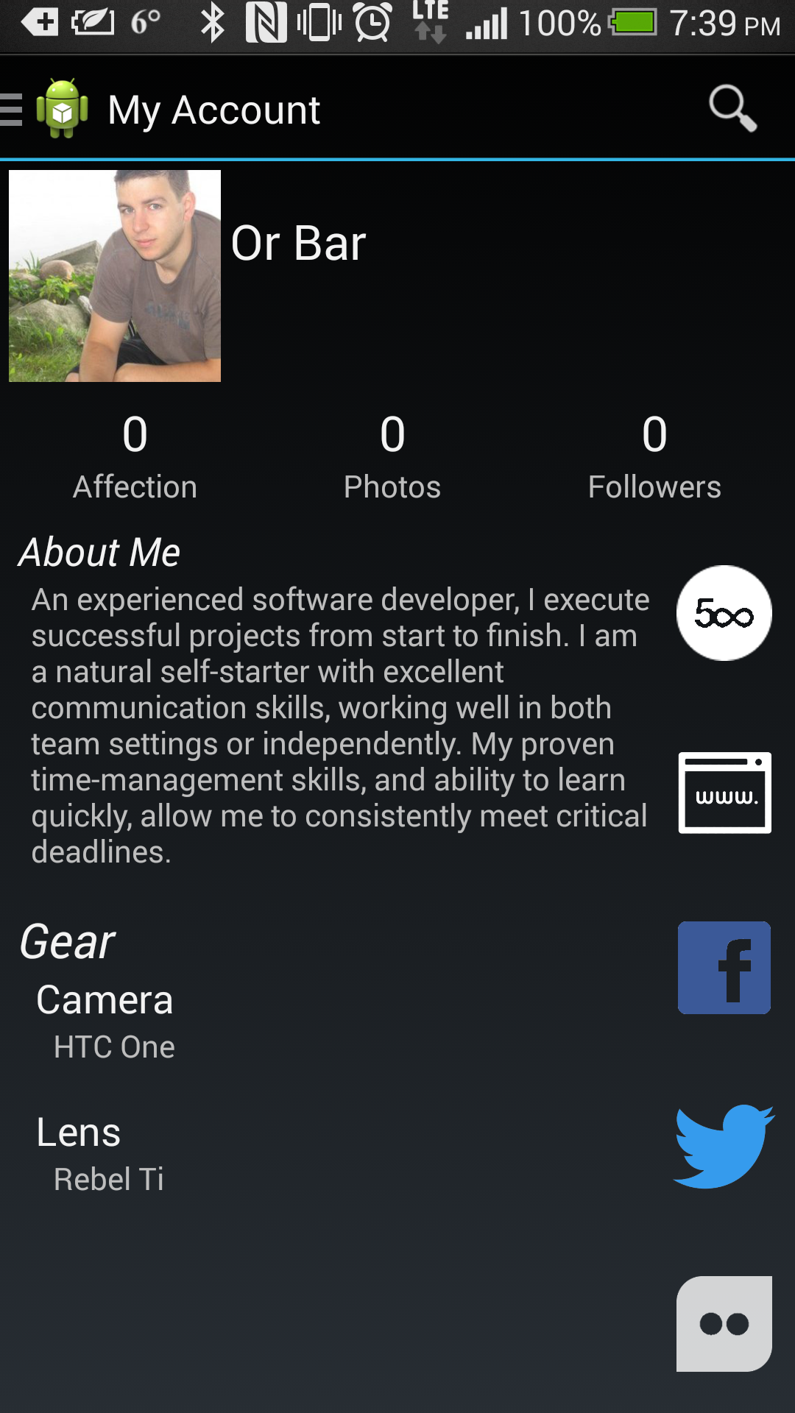

## Appendix

All libraries used in this project are opensource and freely available online

* 500px SDK - <https://github.com/500px/500px-android-sdk\>
  + Slightly modified to enable un-liking and un-favoriting
* ActionBar-PullToRefresh Library - https://github.com/chrisbanes/ActionBar-PullToRefresh
* SlidingUpPanel Library - https://github.com/umano/AndroidSlidingUpPanel
  + Slightly modified to enable support for alpha channel
* PhotoView Library Library - <https://github.com/chrisbanes/PhotoView>
* Picasso Library - <https://github.com/square/picasso/>
* Google Play Services Library – Availiable through the Android SDK Manager